Week 2 – Data Preparation, Exploratory Data Analysis, and Insight Generation
Cohort Participation Analysis Report with Visual Insights

1. Introduction
The objective of this analysis is to prepare the student participation dataset for predictive modeling by refining the data, conducting exploratory data analysis (EDA), visualizing engagement patterns, and identifying factors that influence participation across learning opportunities.
The analysis focuses on understanding participation behavior, engagement consistency, opportunity performance, and key indicators that can support future machine learning models.

2. Data Preparation and Cleaning
2.1 Data Cleaning Activities
The following data preparation steps were performed:
- Handling Missing Values
- Missing numerical values were replaced using median values.
- Missing categorical values were replaced using mode values.
- Records with excessive missing information were removed where necessary.
- Duplicate Removal
- Duplicate records were identified and removed to prevent biased analysis.
- Standardization
- Date formats were converted into a consistent datetime format.
- Column names were standardized.
- Categorical fields were cleaned and normalized.
- Data Validation
- Invalid entries were identified and corrected.
- Data types were verified and converted appropriately.

2.2 Feature Engineering
Several new features were created to improve analysis and future prediction performance.
Derived Features
- Signup Month
Extracted from signup date to identify seasonal trends.
- Signup Day
Used to analyze participation behavior across weekdays.
- Signup Weekday Index
Numerical representation of weekdays.
- Engagement Intensity Score
Combined engagement metrics such as:
- Engagement Intensity =
Clicks + Views + Sessions
- This feature provides a consolidated measure of student activity.
- Opportunity Category Encoding
Opportunity types were transformed into structured categories suitable for analysis.

3. Exploratory Data Analysis (EDA)
3.1 Participation Overview
The dataset was analyzed to understand participation distribution across opportunities.
Key Findings
Participation was not evenly distributed across opportunity types.
Certain opportunity categories attracted significantly more student interest.
A small number of opportunities generated the majority of participation.
Visualization 1: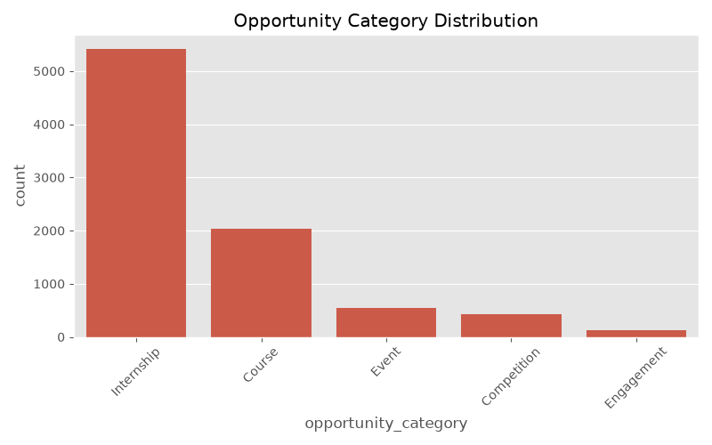
Insert: Signup Distribution by Opportunity Type

3.2 Participation Trends Over Time
Monthly participation trends were analyzed to understand consistency.
Findings
Participation varied across different time periods.
Some months experienced noticeable growth in student engagement.
Seasonal effects may influence participation rates.
Visualization 2: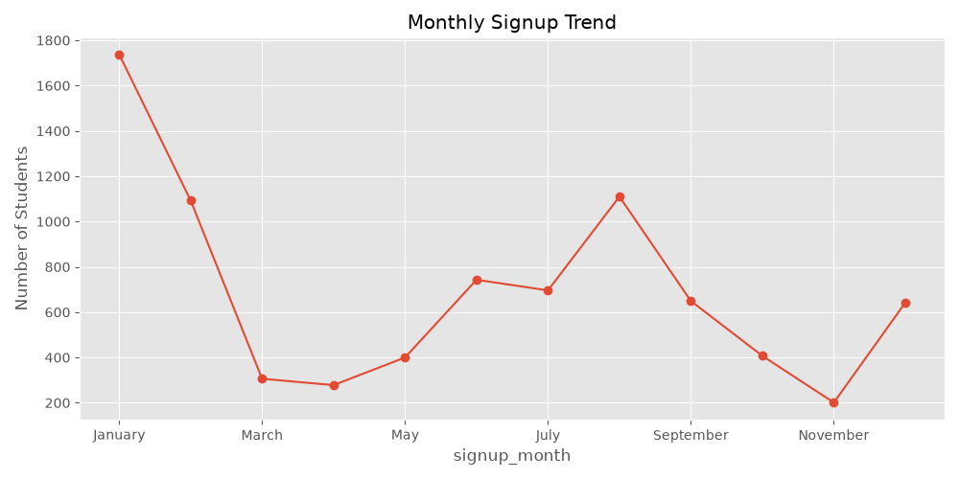

3.3 Engagement Analysis
Student engagement behavior was examined using the Engagement Intensity Score.
Findings
Students with higher engagement scores were more likely to participate.
High-engagement students showed greater consistency across opportunities.
Low-engagement students were less likely to convert into active participants.
Visualization 3:
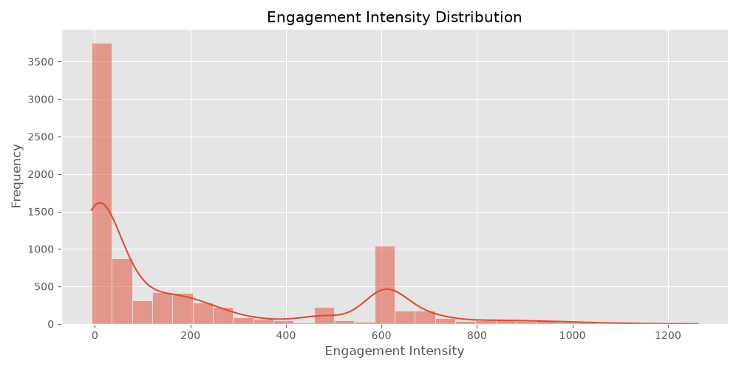

3.4 Correlation Analysis
Relationships among numerical variables were investigated.
Findings
Engagement-related variables showed positive correlation with participation.
Certain metrics appeared to be strong indicators of opportunity success.
Some variables demonstrated little predictive value.
Visualization 4: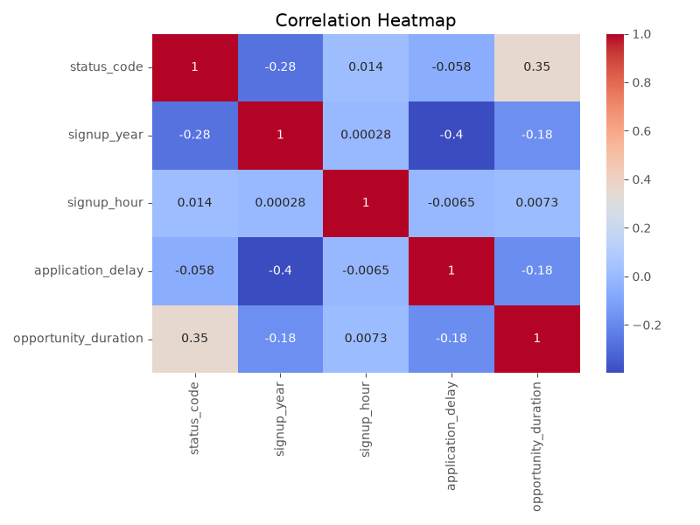

3.5 Anomaly Detection
Outlier analysis was performed using the IQR method.
Findings
A small subset of students displayed exceptionally high engagement.
These users may represent highly active learners or exceptional cases.
Outliers were retained because they provide valuable behavioral insights.
Visualization 5: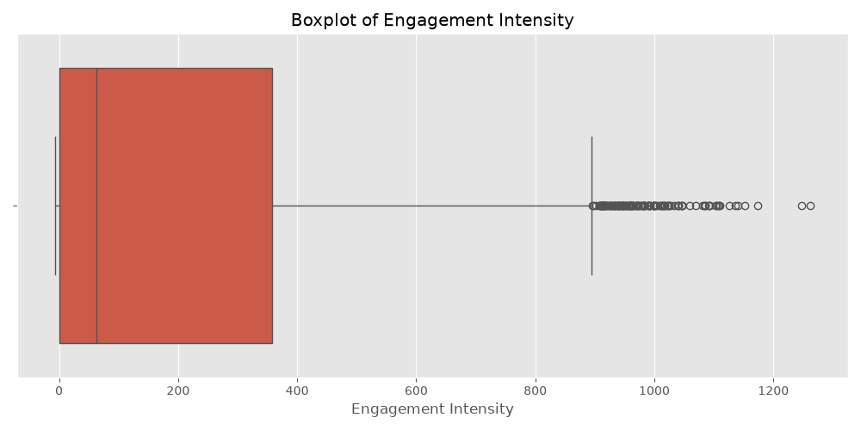

4. Interpretation of Findings
- Factors Influencing Participation
The following factors were identified as major drivers of participation:
- Engagement Intensity
Students with greater interaction levels demonstrated higher participation likelihood.
- Opportunity Type
Certain opportunity categories consistently attracted stronger participation.
- Timing of Signup
Early signups were associated with higher completion and participation rates.
- Consistency of Engagement
Students who interacted regularly were more likely to participate repeatedly.

Early Indicators of High Participation
The following signals may predict successful opportunities:
- High initial signup rates
- Strong early engagement activity
- Consistent participation throughout the opportunity lifecycle
- Positive interaction trends during the first few days

Early Indicators of Low Participation
Potential warning signs include:
- Low initial signup volume
- Declining engagement shortly after launch
- Irregular participation patterns
- Low average engagement intensity

5. Preparation for Predictive Modeling
The dataset is now suitable for predictive modeling activities planned for Week 3.
Readiness Assessment
✔ Missing values handled
✔ Duplicates removed
✔ Data standardized
✔ New predictive features engineered
✔ Outliers investigated
✔ Relationships between variables explored
✔ Participation patterns documented

Features Recommended for Machine Learning
The following variables are expected to provide predictive value:
- Engagement Intensity Score
- Opportunity Type
- Signup Month
- Signup Day
- Historical Participation Count
- Session Activity Metrics
- Interaction Frequency
Potential target variable:
- Participation Status (Participated / Not Participated)

6. Key Recommendations
- Focus future opportunities on categories with consistently high participation.
- Encourage early engagement through reminders and onboarding activities.
- Monitor engagement intensity as an early predictor of participation success.
- Develop predictive models using engineered engagement features.
- Investigate opportunities with unusually low participation to improve design and outreach.

7. Conclusion
The Week 2 analysis successfully transformed the dataset into an analysis-ready format and uncovered meaningful participation patterns. Exploratory analysis revealed that engagement intensity, opportunity type, and signup timing are among the strongest indicators of participation. These findings establish a solid foundation for predictive modeling and recommendation development in Week 3.

